James Young

November 12, 2019

12.08 Assignment

**Explain the principles of divide and conquer and recursion in a personally meaningful way (i.e., don't just repeat facts).**

In programming, recursion is a way to solve problems by having a function call itself. There are many ways to do this, such as using the divide and conquer method, where you break down a complex problem into series of successively simpler, smaller problems. For example, a cooking recipe uses the principles of recursion as it breaks down a food into smaller ingredients and procedures.

**Relate the explanation to a real-world example. Illustrate your presentation with some form of art, graphics, audio, music, animation, video, etc.**

One example of recursion in real life is an art form known as the Droste Effect. Pictures using the Droste Effect would have a smaller image of itself within the picture, which is similar to the idea of recursion. For example, the picture below of the 1904 Droste cacao tin shows recursion, as the lady is holding a smaller Droste cacao tin.

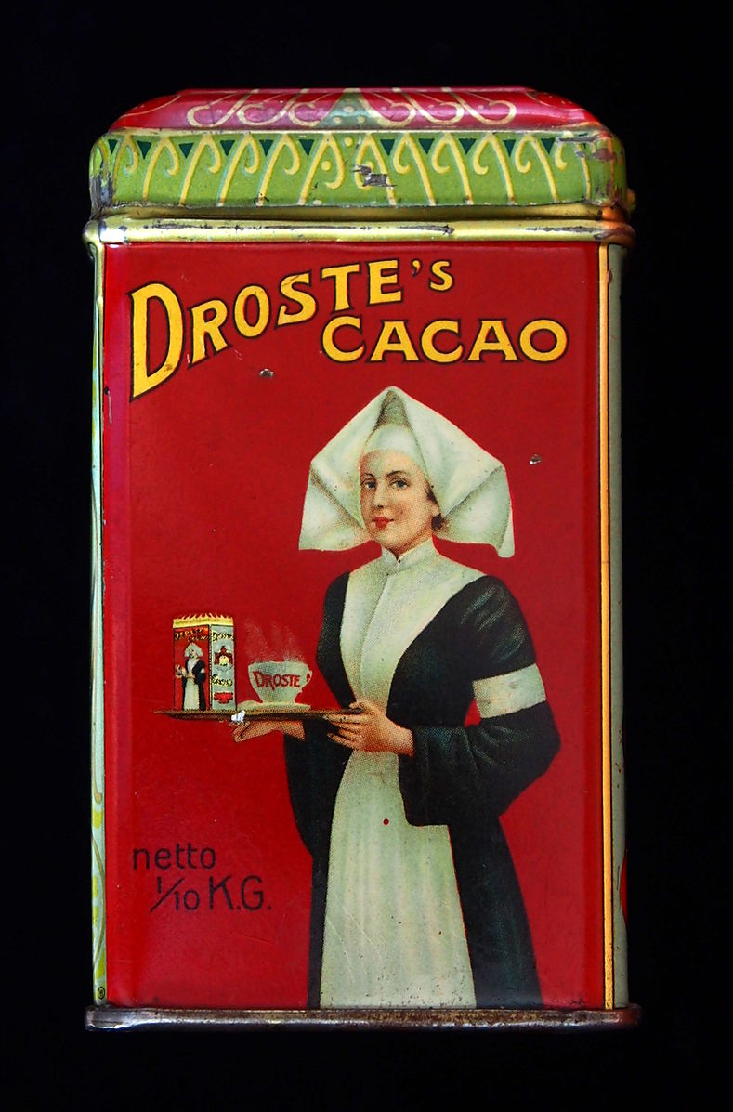

(Source: <https://en.wikipedia.org/wiki/Droste_effect>)

**Provide one example of an original recursive program or problem (e.g., Piecewise function). Document the solution to the program with the S-S-S Strategy. Use the module examples as a guide.**

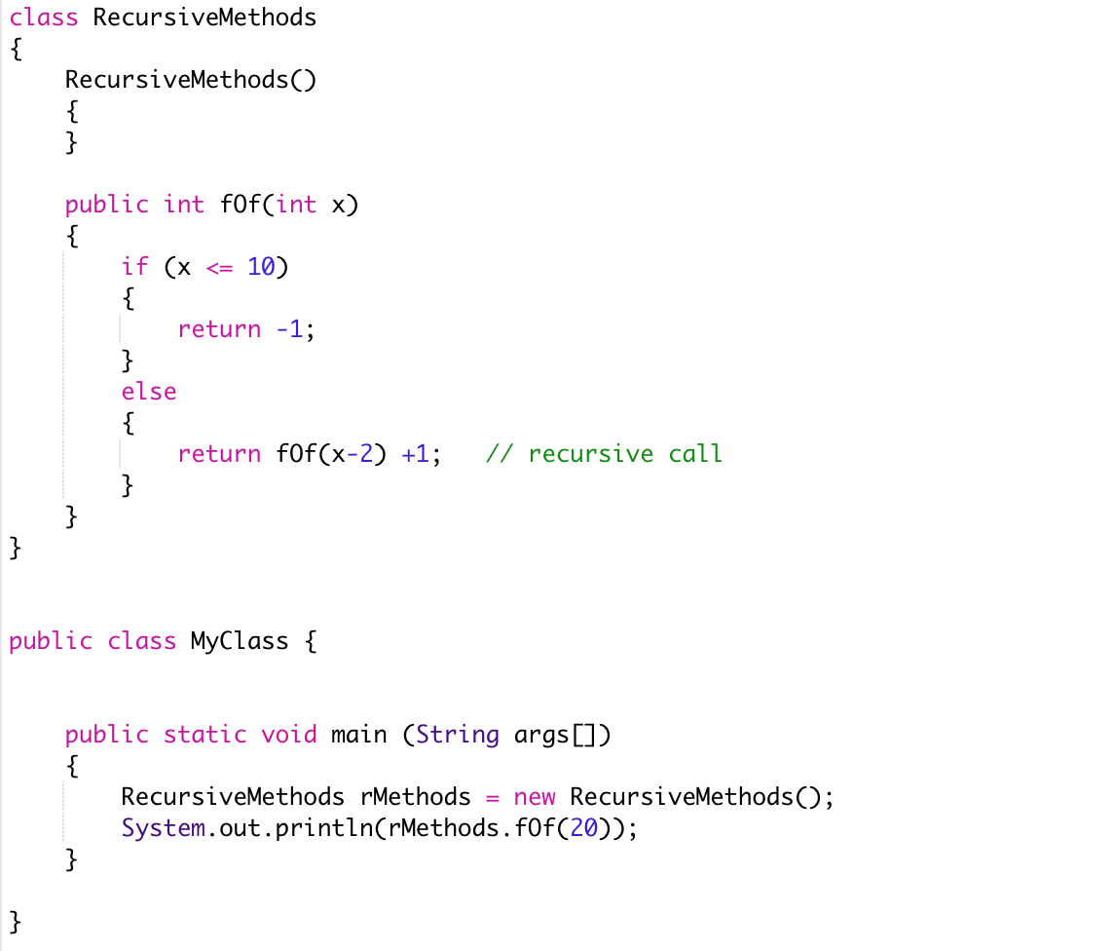

Simplify:

f(20) = f(20-2)+1

f(18) = f(18-2)+1

f(16) = f(16-2)+1

f(14) = f(14-2)+1

f(12) = f(12-2)+1

f(10) = -1

Substitute:

f(12) = -1 + 1 = 0

f(14) = 0 + 1 = 1

f(16) = 1 + 1 = 2

f(18) = 2 + 1 = 3

f(20) = 3 + 1 = 4

Solve:

f(20) = 4